**Assignment 2**

1. **Which field of the Customers table is the primary key?**

In the CUSTOMERS table, the field Cnum (Customer Number) is the primarykey.

A primary key uniquely identifies each record in the table, and in this case, Cnum is used to uniquely identify each customer. It ensures that no two customers can have the same Cnum value, making each entry in the table distinct.

1. **What is the 4th column of the Customers table?**

4th colomn is Rating.

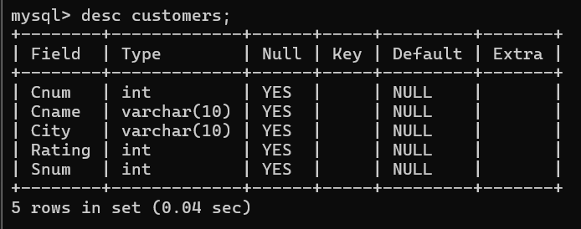

1. **3) What is another word for row? For column?**

Another word for "row" is "record" or"tuple". A row represents a single entry in a table, containing data across multiple fields .

Another word for "column" is "field" or "attribute". A column represents a specific type of data, such as a property or characteristic of the data stored in the table .

**4) Why isn’t it possible to see the first five rows of a table?**

It may not be possible to see the first five rows of a table in certain cases because SQL does not inherently order rows unless explicitlyinstructed to do so. Tables in SQL are unordered sets of data, which means that the concept of "first five rows" doesn't naturally exist unless you define an order.